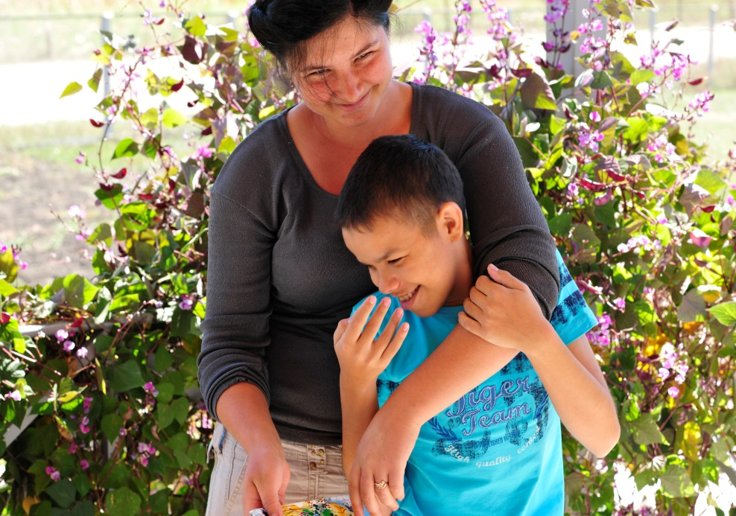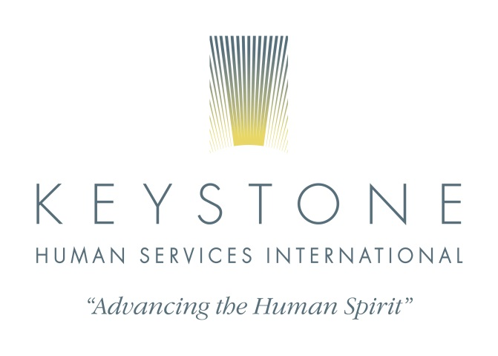
May 16-25th, 2017
JOIN US ON A TRIP THAT MAY CHANGE YOUR LIFE!
ENJOY THE CULTURE, CUISINE AND HOSPITALITY OF MOLDOVA
SEE FIRST HAND THE LIFE CHANGING RESULTS THAT DEDICATED, HIGHLY SKILLED HUMAN SERVICES PROFESSIONALS CAN MAKE ON THE LIVES OF CHILDREN AND ADULTS WITH DISABILITIES AND THE COMMUNITIES THEY LIVE IN.
TOUR LEAD BY Ludmila Malcoci, Ph.D. Project Director Moldova
Ann Moffitt, ACFRE, Vice President KHS
$4200 includes airfare, in country transportation, hotels, most meals and internet access. (Daily schedule subject to change)
Day 1 Leave Harrisburg Mall (or other location) and travel in comfort to Dulles Airport, Washington DC
Flight from Dulles to Munich
Day 2 Flight from Munich to Chisinau, bustling capital of Moldova
Travel to Hotel Regency, a lovely European style small hotel in the heart of the city
Lunch at the hotel
Time to rest
Dinner at lovely culturally focused LaTaifas Restaurant
Day 3 Breakfast at your hotel
Meet at Keystone Moldova office to learn about in-country activities
Visit to Cricova Winery with lunch
Visit Keystone Moldova Training Center.
Dinner together in Chisinau center city restaurant
Day 4 Breakfast at your hotel
Visit the town of Orhei, where the boy’s institution is located. Visit a supported living community home in Orhei
Lunch at Butuceni Restaurant
Visit to Orheful Vechi, a historical and archeological complex
Free time for dinner in Chisinau center city
Day 5 Breakfast at your hotel
Travel to village of Tudora and visit program center and museum
Visit Purcari Winery
Lunch
Visit a community home in Anenii Noi
Dinner at a restaurant in Chisinau center
Day 6 Breakfast at your hotel
Visit to supported living program in Lapusna
Lunch at La Vatra beautiful restaurant in Chisinau
Afternoon Chisinau City Tour with a guide
Free time for dinner
Day 7 Breakfast at your hotel
Visit a supported living program in Falesti
Lunch with the group
Visit a shared living program in Ungheni
Attend a cultural event and dinner in Chisinau center.
Day 8 Breakfast at your hotel
Transport to the airport to travel to Vienna
Transport to your lovely 4 star hotel
Lunch with the group in Vienna
City tour of Vienna with guide
Dinner with the group
Day 9 Breakfast at your hotel
Morning free time
Lunch free time
Group tour in afternoon
Travel to quaint village for dinner
Day 10 Breakfast at your hotel
Transportation to airport for homeward trip
Arrive Dulles evening
Transport to Harrisburg Mall

For information about this exciting trip contact Ann Moffitt at amoffitt@keystonehumanservices.org or 717-232-7509 ext. 133 or cell 717-856-4428

Visit our website www.KeystoneHumanServices.org to learn more about the life changing work of Keystone Human Services Moldova Association and much more.

Registration $500 by March 1st, balance due by April 15th, 2017

